1. 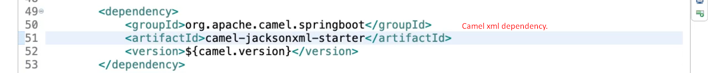
2. Graphical user interface, text, application, Word

   Description automatically generated
3.   
     
   The above app is 🡺 camel-microservice-b which is receiver.
4. We also need sender which will send xml into the queue  
   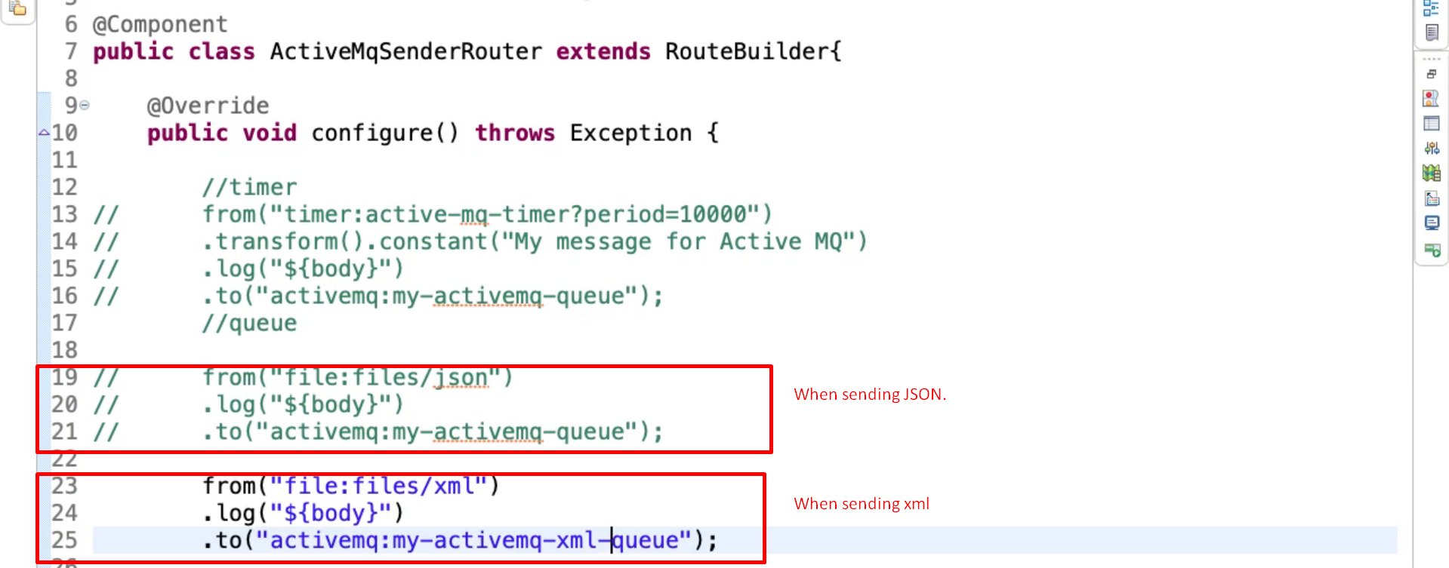  
     
   Table

   Description automatically generated